**MIT School of Engineering**

**Department of Computer Science and Engineering**

**Mini Project Synopsis**

**Date: 06/09/2021**

**Group ID: 09**

**Project Title: Car Recommendation System**

**Group Members: 4**

|  |  |  |  |  |
| --- | --- | --- | --- | --- |
| **Enrollment**  **Number** | **Roll No.** | **Name of student** | **Email Id** | **Contact**  **Number** |
| MITU19BTCS0001 | 2193032 | Aman Bharti | amanbharti751@gmail.com | 7859073654 |
| MITU19BTCS0002 | 2193033 | Aman Raj | rajbuilderaman@gmail.com | 9931607258 |
| MITU19BTCS0169 | 2193088 | Chinmay Mandavkar | chinmaymandavkar@gmail.com | 9082990473 |
| MITU19BTCS0014 | 2193104 | Gaurav Kumar | gaurav22102000@gmail.com | 8875264409 |

**Problem Statement:** To Recommend the best match of car to the customer using machine learning algorithms.

**Abstract:**

Having a vehicle has become a mandatory requirement in the modern world due to the complex life style of the people. There are various types of domestic vehicles are available in the market. Some of them are multi-purpose and some are used for specific purposes. Automobile industry investing a lot on producing different car models to cater the needs of their customers with different social and economic backgrounds. So, the prices of the vehicles with the same features varies in a wide range. Thus, choosing the most appropriate vehicle is a challenging task for the customers who are planning to buy a vehicle. It requires technical expertise to some extent and guidance to make the right choice by analyzing the customer’s requirements. Thus, most of the vehicle buyers seek services from experts or consultants before buying a vehicle. Therefore, we are investigating a potential solution for this issue using modern machine learning technologies.

**Literature Survey :**

Recommendation system has an immense business values and it enhances customer experience by using its expertise knowledge to suggest best matching items to users.

There are number of recommendation approaches and methods have been proposed by the past research.

Collaborative filtering and knowledge based filtering are generally the most popular memory based filtering methods. The main advantage of Collaborative filtering is it provides serendipitous recommendations because its recommendations are based on user’s similarity and their purchasing behaviour [1].

Nevertheless, collaborative filtering suffers from ‘complete cold start problem’ where no rating record are available and ‘incomplete cold start problem’ where only a small number of rating records are available for some new items or users in the system [2]. However, Knowledge-based filtering can avoid some of the disadvantages in Collaborative filtering method.

User feedback is an important factor to improve the effectiveness of recommendation algorithms. User feedback component consists of two levels external and internal. External feedback is to collect information from open platforms like automobile websites, social media etc. Internal feedback is there to collect information from users who got recommendations. Combining both, some researches have introduced feedback based collaborative filtering methods as well [3].

Most of the existing recommender systems are based either on a content based approach or collaborative filtering approach. However, recent research have shown that hybrid recommender algorithms which is a combination of both collaborative filtering and knowledge based filtering produce better personalised recommendations [4].

Collaborative variational autoencoder (CVAE) considers both rating and content for recommendation in multimedia scenario. The model learns potentially deep representations of content data in an unsupervised way. And also learns indirect relationships between items and users from content and rating. Experiments have shown that CVAE can perform really well the state-of-the-art recommendation methods with more robust performance [5].

**Proposed System :**

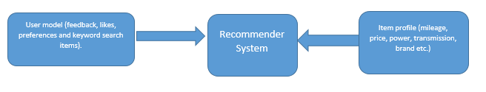

**Fig**.1General model

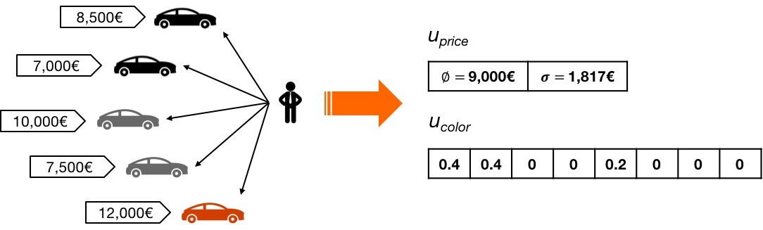

**Fig**.2

**Conclusion:**

As the global market rises and the demand of new brands on Indian economy leads to arrival of new models. All outside car manufacturers see Indian market as their place to grow in their share on global car economy. As world moves to the peak of a new era, recommendation become an unavoidable fact. Almost all the technical and non-technical things in today’s world wave hands to recommendation. The main fact that the recommendations got deeply rooted in new technology is due to its accuracy, precision and reliability. The main problem with car data-set is that they are dynamic data because it is difficult to predict the car model that will be expelled from their brand.

**References:**

[1] D. Yadav, A. Singh, and V. Kr, “A movie recommender system: Movrec,” International Journal of Computer Applications, vol. 124, pp. 7–11, 08 2015.

[2] J. Wei, J. He, K. Chen, Y. Zhou, and Z. Tang, “Collaborative filtering and deep learning based recommendation system for cold start items,” Expert Systems with Applications, vol. 69, 10 2016.

[3] B. Krishnamurthy, N. Puri, and R. Goel, “Learning vector-space representations of items for recommendations using word embedding models,” Procedia Computer Science, vol. 80, pp. 2205–2210, 2016.

[4] L. Thomas and V. Vaidhehi, “The design of web based car recommendation system using hybrid recommender algorithm,” International Journal of Engineering Technology, vol. 7, p. 192, 06 2018.

[5] X. Li and J. She, “Collaborative variational autoencoder for recommender systems,” Proceedings of the 23rd ACM SIGKDD International Conference on Knowledge Discovery and Data Mining - KDD ’17, 2017. [Online]. Available: http://cseweb.ucsd.edu/classes/fa17/cse291-b/reading/p305-li.pdf

**Annexure:**

**Annexure 1: Form A-Title Approval**

**Annexure 2: Form B-Market and financial feasibility**

**Annexure3: Literature Survey Paper**